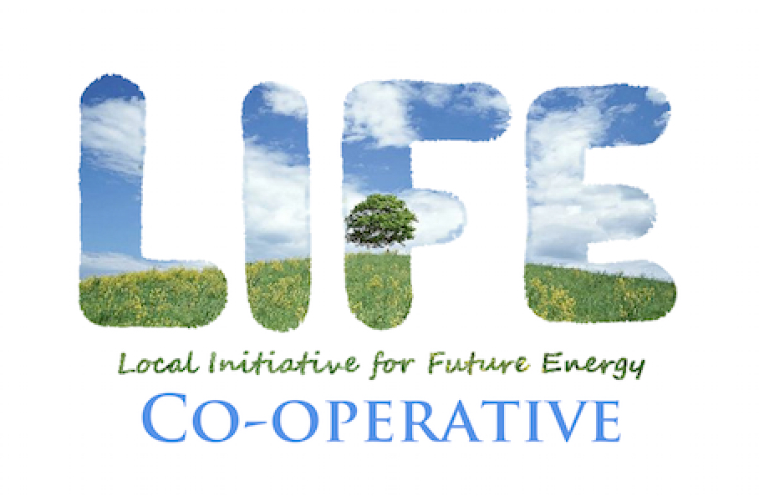
LIFE’s Community Fund 2023: APPLICATION

Hello, and thank you for your interest in applying to LIFE’s Community Fund. We look forward to hearing your responses to the questions below. Please complete this application – use as much space as you need – and any accompanying documents and return as a single PDF file, to communityfund@lifecoop.ca, by midnight on Thursday, November 30, 2022.

We intend to let all applicants know our decisions by mid-December.

1. Applicant Organization name.

2. Organization type (charity / NFP / unregistered community group / other _________________.

3. Describe your organization’s vision, mission and goals. If your organization has a mission statement, please provide it here.

4. Describe the project or initiative the funds will be used for. Please include proposed date(s) and location(s) of any activities. Preference will be given to projects in Waterloo Region and Wellington County.

5. Describe the specific community or group (including non-human communities) that will most directly benefit from your project. Who are you doing this for? Also indicate the broader impact or reach the project could have. Is it designed for replication? How might it contribute to cultural change?

6. Please provide a draft budget for the project as a whole. Show clearly the specific purpose for which the LIFE Community Fund award will be used (wages, food, rentals, printing…).

7. Tell us how you plan to acknowledge LIFE’s contribution to the project.

8. Identify any collaborating organizations that are directly or indirectly involved with your project, and any additional sources of funding for the project, the amount expected, and whether these awards are pending or confirmed.

9. Amount requested: (Max. $1500 for incorporated entities, $500 for non-incorporated groups)

10. Contact information.

Name of contact person:

Role at organization:

Contact phone number:

Email:

Physical/postal address:

Applicant website/LinkedIn/Facebook URL:

