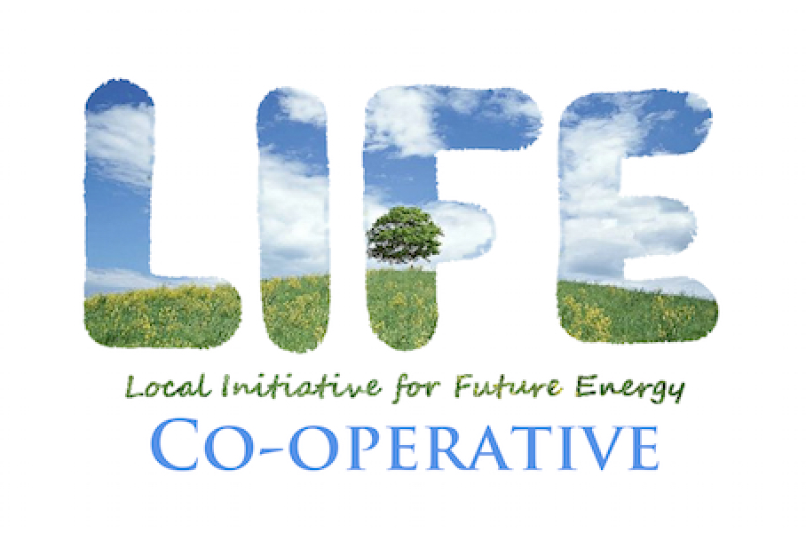
LIFE’s Community Fund 2018: APPLICATION

Please copy and paste the points below to a Word or similar file, and answer as completely as possible. We ask that your application be returned as a PDF file to communityfund@lifecoop.ca by November 15, 2018.

1. Applicant Organization name.

2. Organization type (circle):

charity non-profit community group

other ________________________________.

3. Describe your organization’s vision, mission and goals. If your organization has a mission statement, please provide it here.

4. Describe the project or initiative the funds will enable, including proposed date(s) of activities.

5. Describe the community that will be affected by or benefiting from your project, and the overall impact the project will have.

6. Please provide a draft budget for the project, and indicate clearly the specific purpose for which the LIFE Community Fund award will be used.

7. Identify any collaborating organizations that are directly or indirectly involved with your project.

8. Identify any additional sources of funding for the project, the amount expected, and whether these awards are pending or confirmed.

9. Amount requested.

10. Contact information.

Name of contact person:

Role at organization:

Contact phone number:

Email:

Physical/postal address:

Applicant website/LinkedIn/Facebook URL:

